
Human Biology – General Year 11 Task 9 – Unit 2

Assessment type: Test
Conditions:
Period allowed for completion of the task:
- One revision lesson in class
- One lesson conducting test in class
Task weighting: 7% of the school mark for Units 1 and 2 ___________________________________________________________________________ Task 9: Test- DNA, Cells and the Reproduction (45 marks)
Multiple Choice Questions: (10 marks)
- What is the best definition for the term heredity?
  - Learning skills or behaviours
  - The passing of traits from parents to offspring
  - The passing of traits from offspring to parents
  - A form of reproduction

- What do we call the characteristics of an organism?
  - Appearances
  - Personality
  - Genetics
  - Traits

- What codes for the characteristics of an organism?
  - The brain
  - DNA in cells
  - The skin of an organism
  - None of the above

- Which of the following is NOT an inherited trait?
  - Eye colour
  - Hair colour
  - Height
  - Ability to read

- Which haploid cell(s) are known as gametes?
  - Egg
  - Sperm
  - Body cells
  - Both a and b

- What is a karyotype?
  - A chromosome abnormality
  - A special pair of chromosomes
  - A picture of an organism’s chromosomes
  - A graph that shows where genes are located along a chromosome

- An organism that is homozygous dominant has:
  - Two dominant alleles
  - One dominant allele and one recessive allele
  - Two recessive alleles
  - Two recessive alleles and two dominant alleles

- According to the Base-Pair Rule...
  - A pairs with C and G pairs with T
  - A pairs with G and C pairs with T
  - A pairs with T and C pairs with G
  - Each nucleotide pairs with itself (e.g. Adenine pairs with Adenine)

- What is a pedigree?
  - A pattern of inheritance
  - A diagram of where genes are located along a chromosome
  - A diagram that shows how a trait is passed through inheritance
  - A picture of a person’s chromosomes

- In each human body cell the number of chromosomes is
  - 27
  - 23
  - 54
  - 46

Short Answer Questions: (33 marks)

11. What are sex chromosomes? (1 mark)
_________________________________________________________________________________________________________________________________________________________________________________________________________________________________

12. What is the difference between an inherited trait and learned trait? (2 marks)
_______________________________________________________________________________________________________________________________________________________________________________________________________________________________________________________________________________________________________________________________________________________________________________________

13. Define genotype and phenotype? (2 marks)
________________________________________________________________________________________________________________________________________________________________________________________________________________________________________________________________________________________________________________________________________________________________________________________________________________________________________________________________________________________________________________________________________________________________________________________________________________________

14. What are the 3 possible combinations of alleles an organism can have for Mendelian traits? (3 marks)
__________________________________________________________________________________________________________________________________________________________________________________________________________________________________________________________________________________________________________________________________________________________________________________________________________________________________________________________________

16. Widow’s peak is controlled by one gene. There are two alleles for this gene: having a Widow’s peak (W) and not (w). The Widow’s peak allele is dominant. Draw a Punnett Square to show what possible offspring could be produced if a heterozygous male has a child with a heterozygous female. What is the probability that the offspring will have a Widow’s peak? (4 marks)

17. Eye colour is controlled by one gene with 2 alleles. The brown eyes of the mother are homozygous dominant and the blue eyes of the father are homozygous recessive. Draw a Punnett Square to show the possible offspring that could result from the two individuals. What is the probability that the offspring will have brown eyes or blue eyes? (4 marks)

18. Complete the following diagram, including the three components of each nucleotide
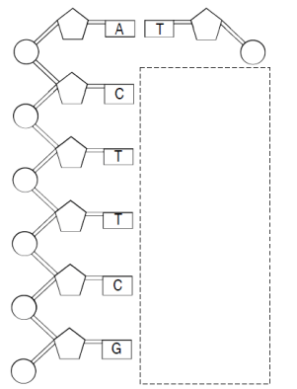
(3 marks)

19. Individuals who lack an enzyme needed to make melanin, the skin pigment, are called albinos. They do not have pigment in their skin and so their skin appears white. The enzyme needed to make melanin is controlled by one gene. The normal skin pigment allele is dominant. The albino skin pigment allele is recessive, so and albino must have two recessive alleles. The pedigree below shows a family affected by albinism. The mother is affected with albinism. She has two sons affected with albinism. She has two daughters who are not affected by albinism.

Shade the symbols of mother and sons in the pedigree below to show they are affected with the disease. Based on this information, predict if the father is affected by albinism. Shade in his symbol if you believe he is affected by albinism. Leave his symbol unshaded if you believe he is not affected.

Why do you think the father is or is not affected by the disease? (4 marks)
__________________________________________________________________________________________________________________________________________________________________________________________________________________________________________________________________________________________________________________________________________________________________________________________________________________________________________________________________

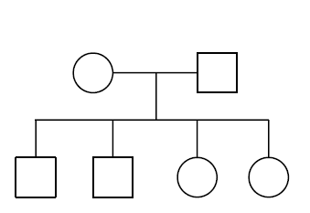

20. Fill in the table (12 marks)

Name | Diagram | Explanation
Interphase

 |  | Double-stranded chromosomes become visible
Metaphase

Anaphase

 |  | 2 nuclei form, each with the diploid number of chromosomes
Cytokinesis

